1. **Import the dataset (’Exercise – Lab 05.txt’) into R and store it in a data frame called ”Delivery Times”.**

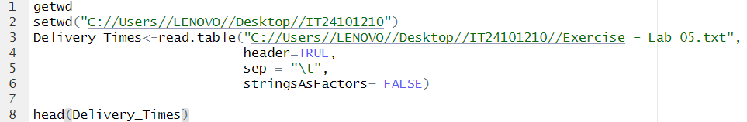

1. **Draw a histogram for deliver times using nine class intervals where the lower limit is 20 and upper limit is 70. Use right open intervals.**

**3.Comment on the shape of the distribution.**

Its rises at first and then falls after the middle, which means its symmetrical.

**4.Draw a cumulative frequency polygon (ogive) for the data in a separate plot.**

